**KPIs to measure and track Kiva’s performance.**

***KPI 1: Loan distribution based on world region, sector and percentage of rural population***

This KPI measures whether different regions have more access to funding as compared with others. It also looks at the behaviours of the loanees in terms of the sectors and rural population percentage. For example, from the following table, it's clear that Arab states take up way less loans(1.69% of the total loans distributed). We can also see that rural area residents are more likely to get loans for heath and agricultural purposes.

*Advantage*: It provides a clear overview of the relationship between loans among different sectors and the rural percentage occupation.   
 *Limitations*:  It does not account for the impact of other credit sources on borrowing behavior in different regions.

The KPI does not clarify what "General Financial Inclusion" entails or why it receives the highest funding.

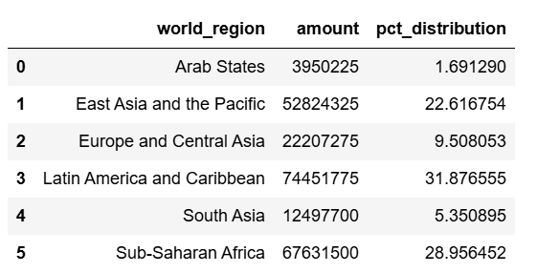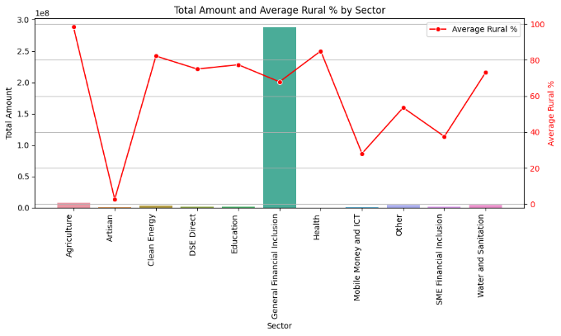

***KPI 2. How gender affects loan distribution and repayment behaviours***

This KPI tracks loan distribution based on gender. It looks at loan amounts advanced to each gender, the sectors where various genders are more likely to use their loans in and the tenor of loans each gender picks.

This KPI helps with looking at any possible gender discrepancies and potential gaps. It can show whether utilization of credit avenues is well distributed. It also might help with financial education initiatives where extreme patterns or behaviours are noticed.  
On the downside, it does not analyze gender differences based on urban versus rural location, which may impact loan usage and repayment behavior.  Additionally, the KPI does not factor in income disparities, which could influence borrowing and repayment behavior.

*Highlight any patterns, trends, areas of concern, or opportunities for improvement, and provide actionable recommendations.*

*Some noticeable trends:*

Men receive fewer loans than women, with 73.16% of loans going to women and only 26.84% to men.

Both men and women tend to take short-term loans, with the vast majority having a tenor of less than twenty months. In every tenor period band though, women still pick the most loans, most likely because most loanees are women.

In terms of usage, women highly use their loans in agricultural, food and retail sectors. Men take up more loans for agricultural purposes but have a more even distribution across other sectors compared to women. Additionally, men take more loans than women for use in the entertainment, transportation, and wholesale sectors.

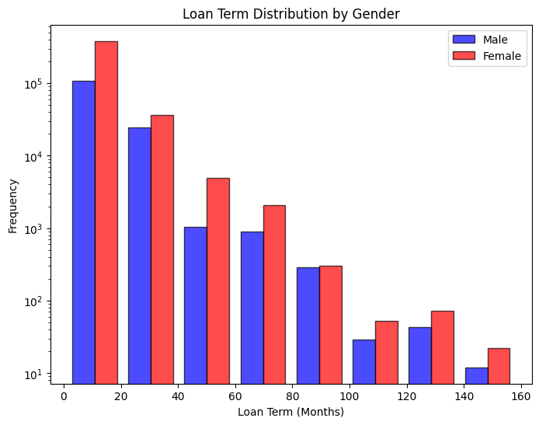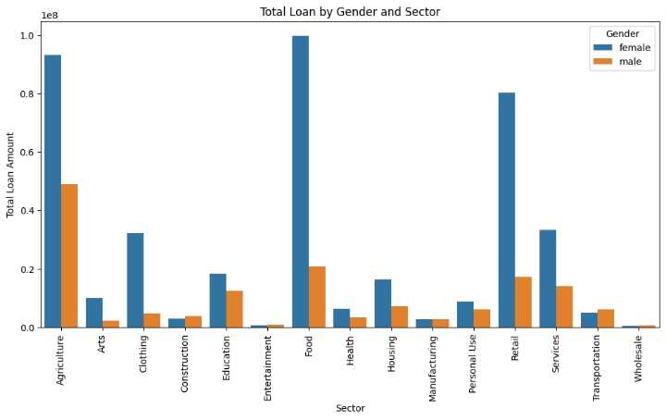

Shorter term loans may also show liability to acquire large amounts of credit or even a dependency on loans which is a problem.

Both men and women rarely invest in sectors like manufacturing and construction, which could significantly boost the economy and support other sectors like agriculture.

Even though we haven't in detail analysed what may cause the trends, it's clear that women may be more likely to take loans for general survival and / or areas that point to the same.

*Areas of concern*

It should be investigated whether the short term loans are more because of over dependence on loans and strategies put in place to mitigate that.

*Recommendations*

Both men and women need to be encouraged to pick up loans to support key sectors like manufacturing.

Given the sectors where women are taking most loans, it needs to be researched whether it's for subsistence or commercial use to ensure we promote commercial activities.

**KPI 3. Loan Funding Speed**

This KPI tracks the period(in days) between when loans are posted and when they are funded per repayment interval and world region.

Loans with weekly repayment intervals take the longest to fund, averaging slightly over 25 days.  On the other hand, those that are repaid irregularly take the least number of days to get funding. Monthly and bullet repayment basis follow each other closely in second and third position respectively.  Loans with irregular repayment schedules receive funding the fastest. On the flip side, weekly repayment loans take the longest to fund, which is an avenue to investigate whether such loans are less attractive to lenders.

In terms of world region, Europe and Central Asia have the longest funding time, averaging just over 17.5 days. Latin America and Caribbean come second in place while East Asia and Pacific come last, with an average of just less than 10 days.

*Advantages*: This KPI helps identify funding delays, allowing Kiva to implement interventions such as promoting slow-funding loans.

*Limitations*: The KPI does not account for factors influencing loan funding speed, such as loan amount differences between regions.